Repository:
https://github.com/duggy64/Budgie/tree/main

Click on “New Project” on the top left toolbar area and enter information prompts.
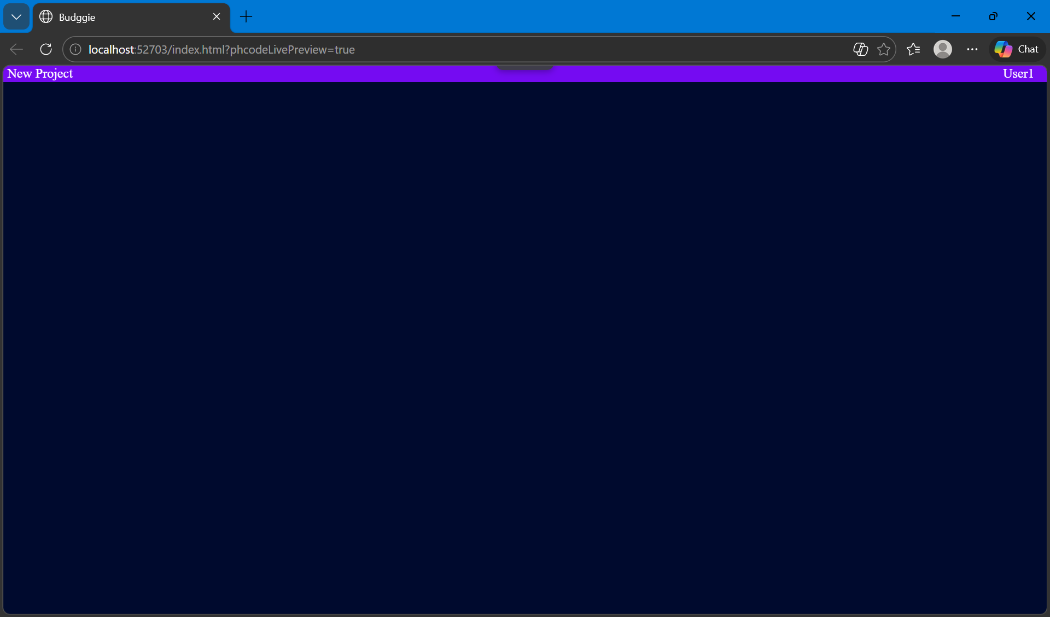

After which you may see a new project created.
Note: The project is hardcoded to the first (element) project. I had trouble with saving session data, but with time I’m sure it can be easily implemented. You can still, however, make more projects.

Clicking on the project will bring you to the main project page.
Here, you may add users and give contributions to your projects individually. Switch users by clicking the user name in the box below the graphs. You can see which user you currently are from the top right username in the toolbar.
Note: You may switch users, but this is meant to be a social app, so it would be other users online. For now, they are hardcoded.
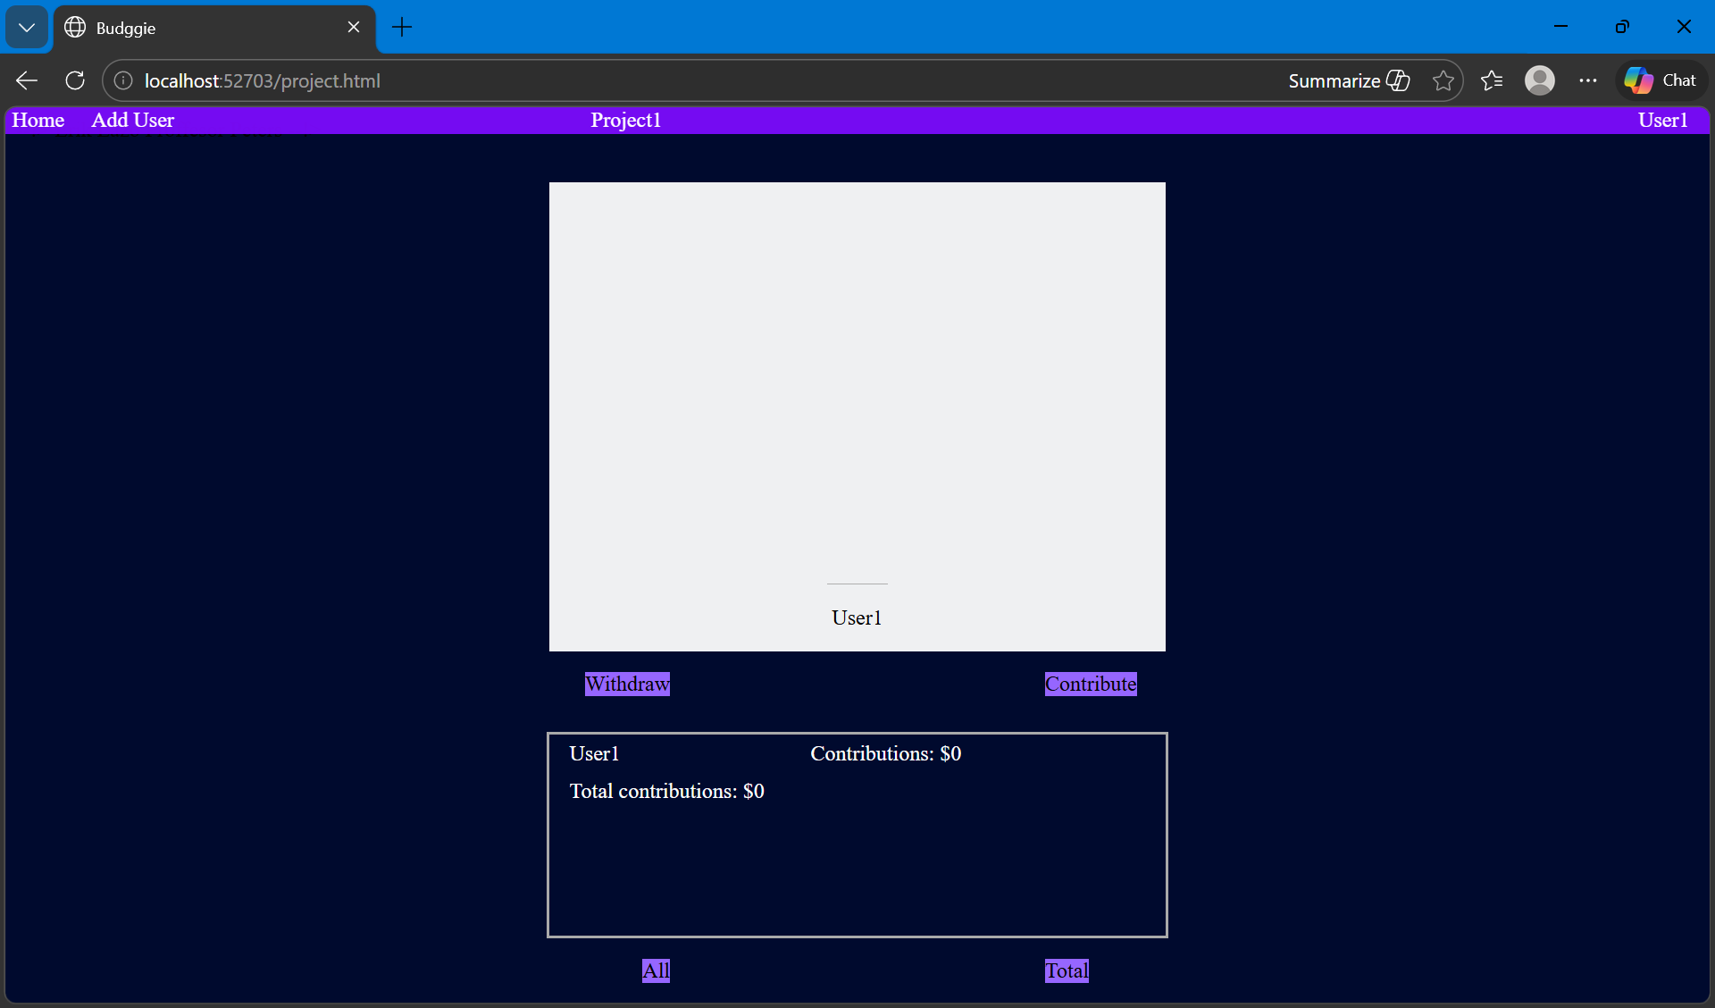

You may view the each individual contribution, or view the total of all users by clicking, all or total button at the bottom.
